**Rutik Khairnar Team A Angular Build Assesment**

1. **NodeJS installation**

We have downloaded the node v22 bineries zip file and then set it up in the user environment variable path.

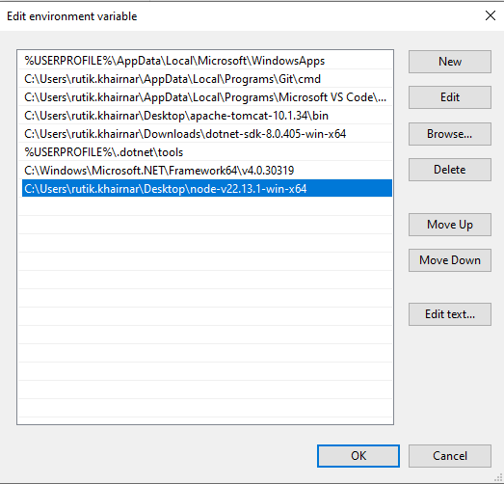

1. **Verify node installation**

>>node -v

>>npm -v

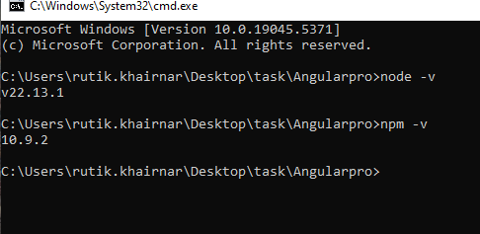

1. **Cloning a repo from Github**

This Project is angular based Task Manger Project .

>> git clone https://github.com/jspvg/task-manager-angular.git

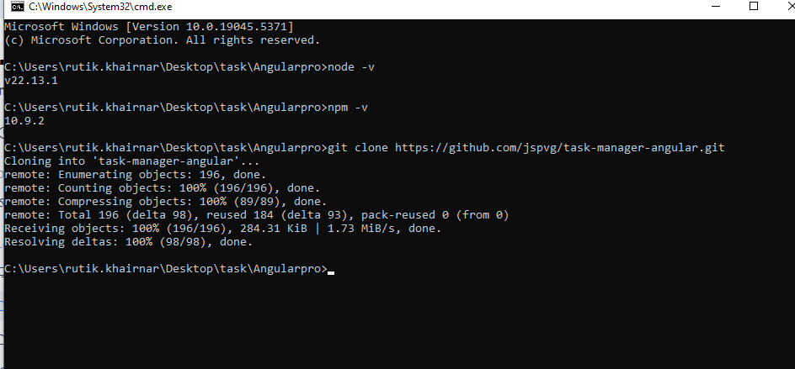

1. **Project folder structure**

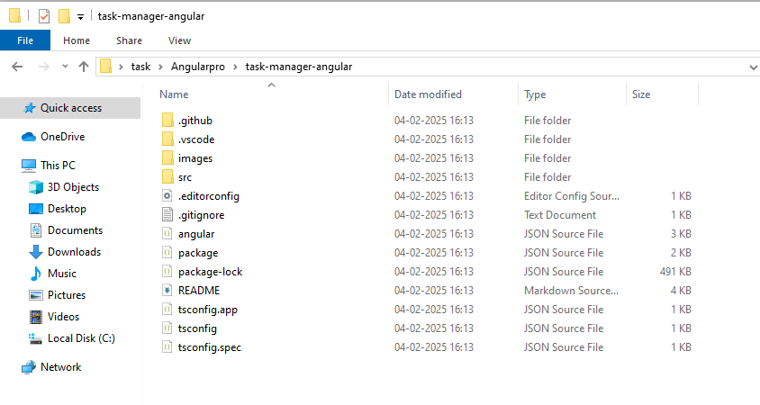

1. **Now installtion the dependencies using the command.**

>>npm install

We have to run this command in the root directory where the package.json file is available

This will create a node_modules folder that will have all of our dependencies installed.

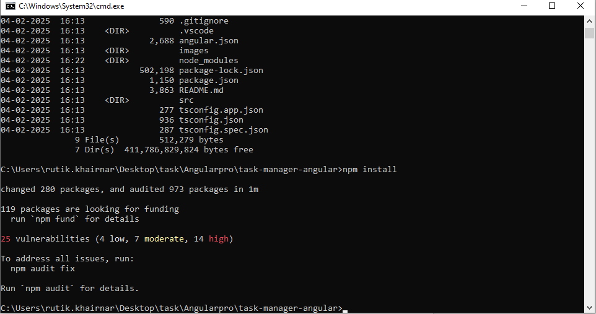

1. **After the installation we will run the project locally using the start script available inside the scripts section in package.json**

>>npm start

While running the project it will create a project-lock.json file which will also have our dependencies but it will be more descriptive.

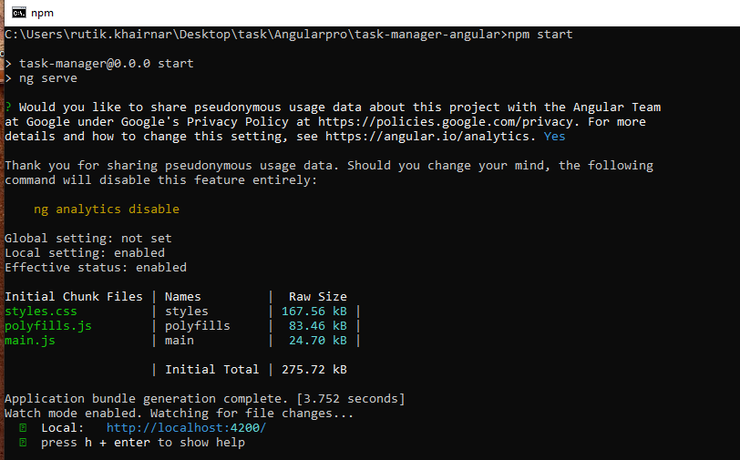

This will run our project on the local server.

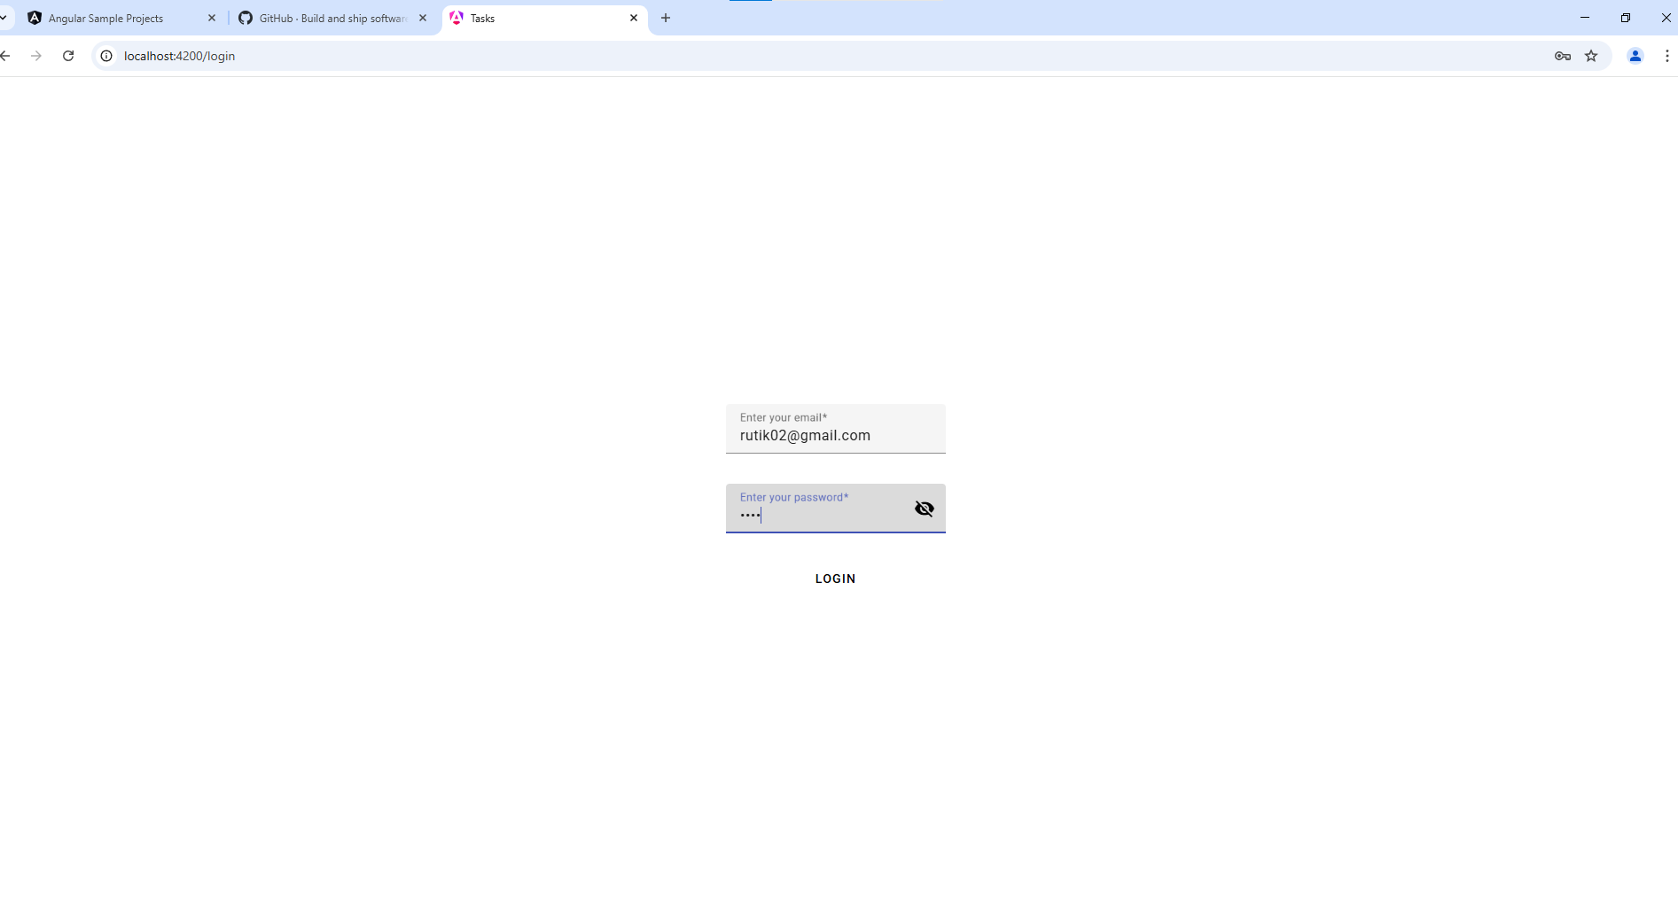

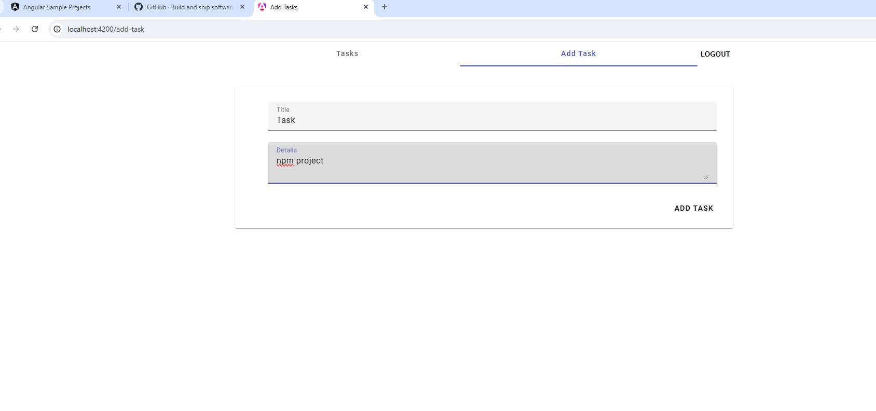

As we can see the project is running successfully on the local environment.

1. **Now we will create our build for the project using the command**

>>npm run build

The above command will run the following angular cli command

>>ng build -c=production

This will create a dist folder in the root of our project with the name of our project.

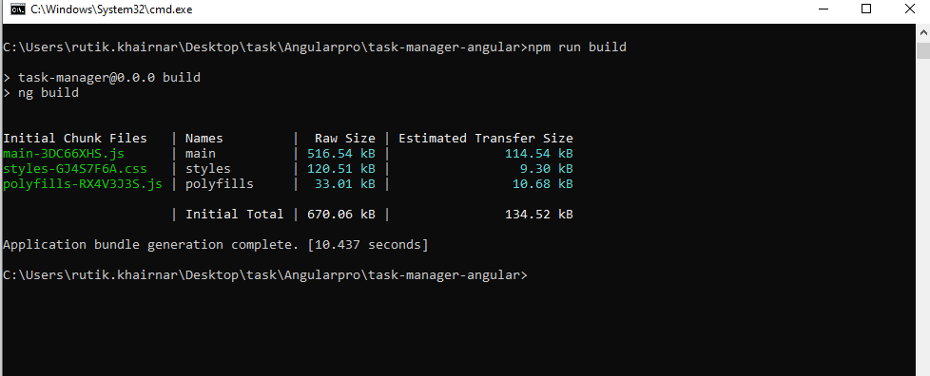

**8.Now our final build is created inside the dist folder.**

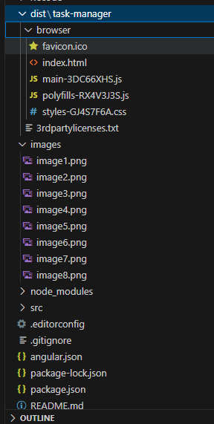

**9.Now that our final build is ready we will try to deploy it on a server to see if its working for our practice we have use the netlify server.**

>> first we have to login to netlify.

>> in the Site section we will go to the Add new Site section we will choose the deploy manually.

>> This will open a window asking for the final build for the deployment.

>> We will choose the browse go to our dist folder and choose the final build folder our project

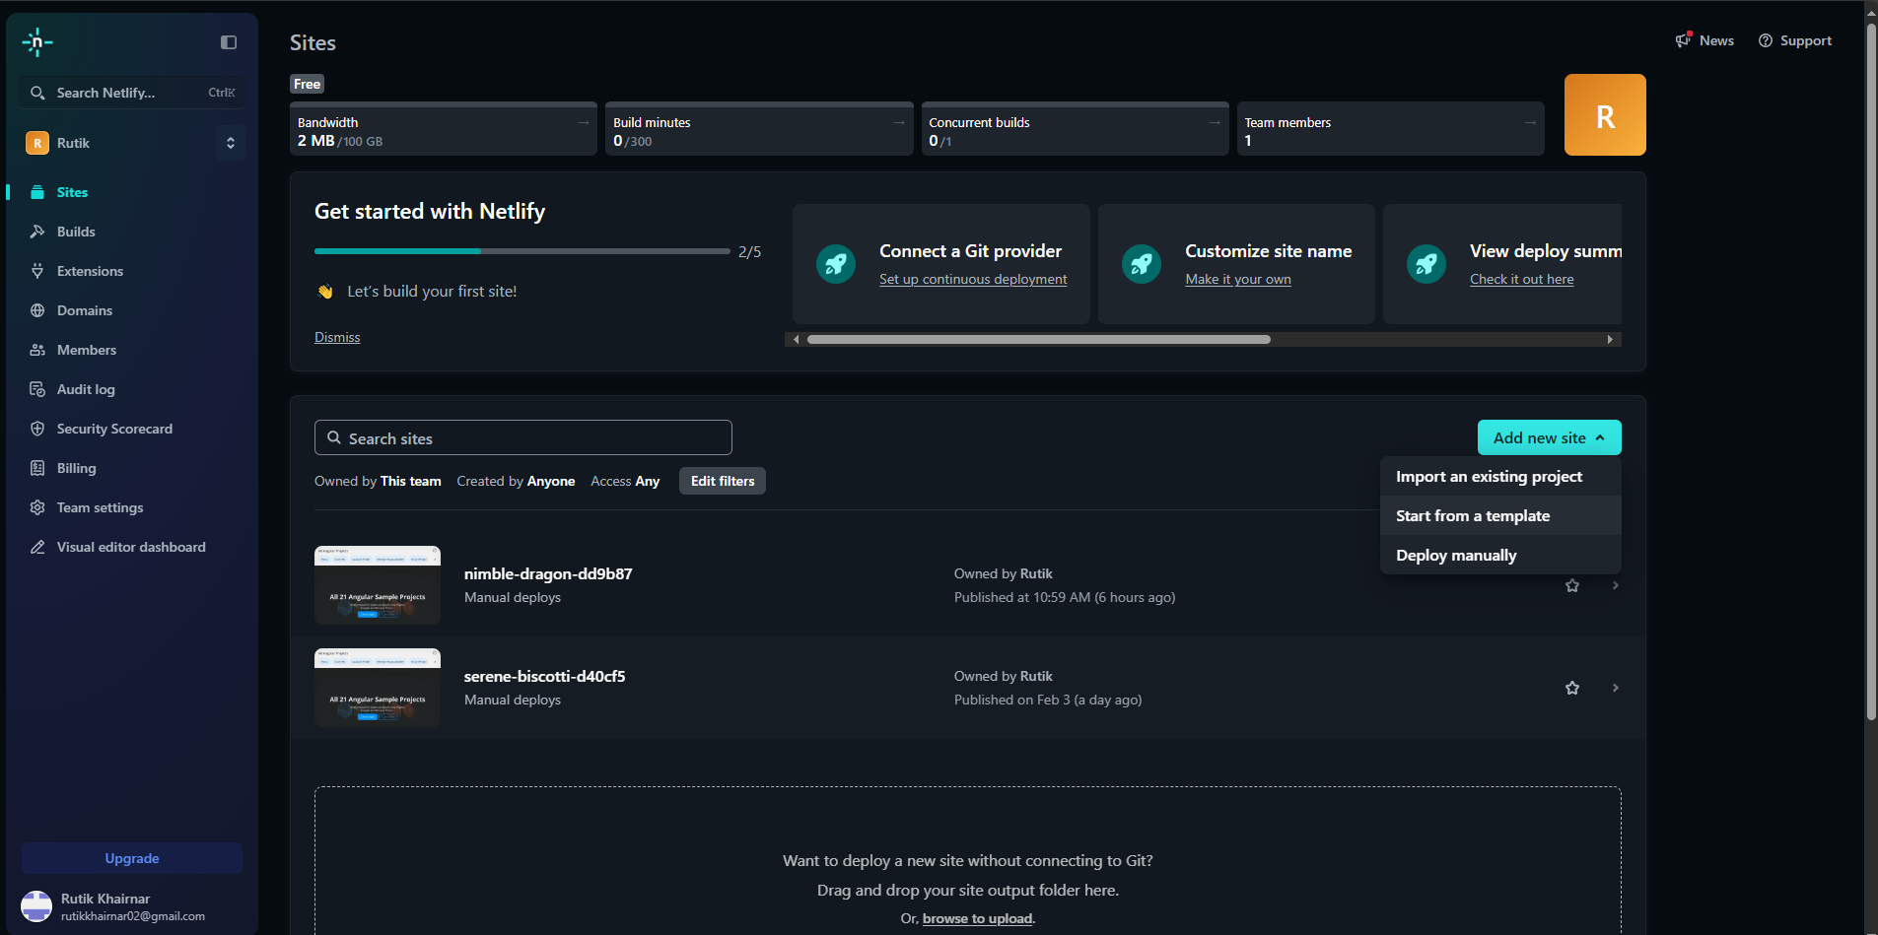

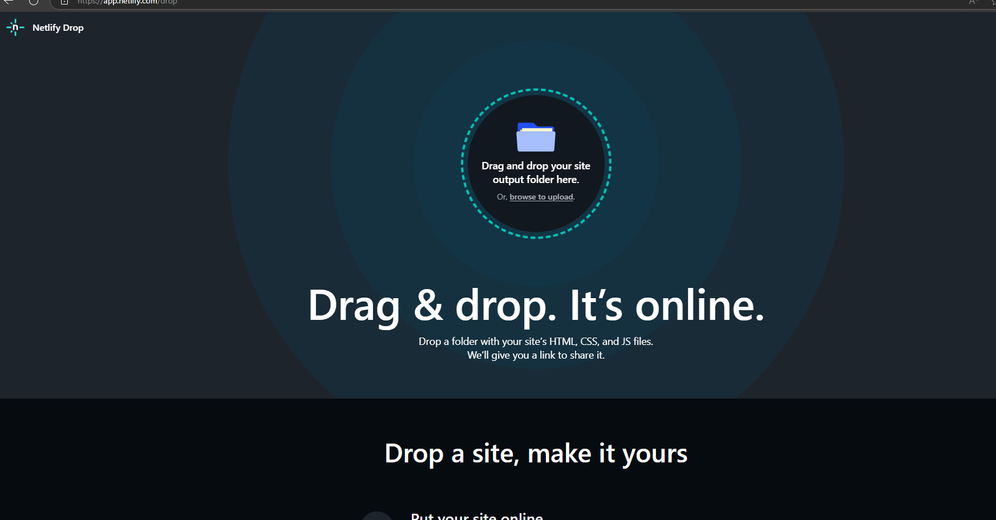

**10.After we deployed the build folder it will redirect us to this page which will have our deployed project logs and url of our website**

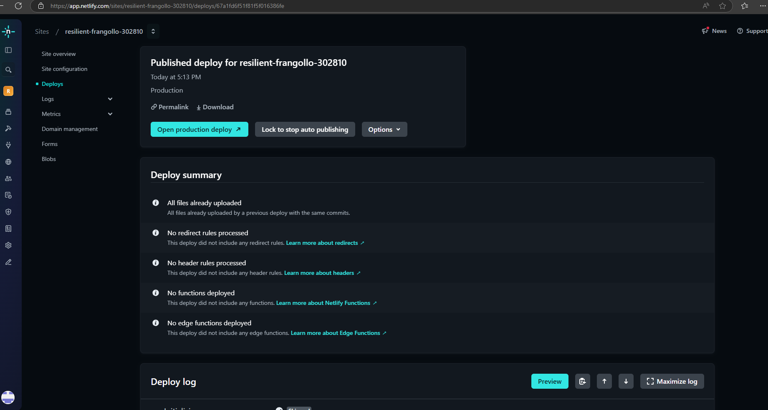

**11 . This is our website opened using our deployed project url.**

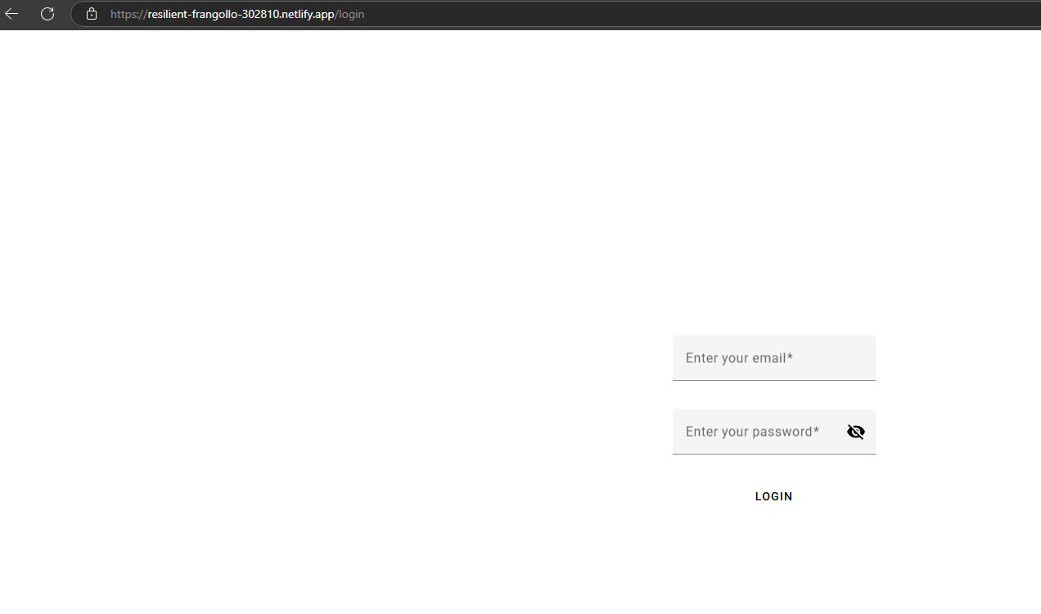

**Link of the deployed app.**

<https://resilient-frangollo-302810.netlify.app/>